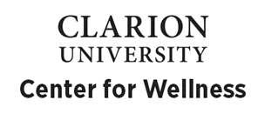

The Center for Wellness is committed to promoting happy, healthy, and successful students. This mission includes collaboration between the Center for Wellness and faculty in order to reach the student population for the purpose of wellness education.

How can we do that?

Center for Wellness staff are available for classroom presentations on the following topics:

- Stress & anxiety
- Depression
- General mental health conditions/concerns
- Relationships – including dating/relationship violence & how to promote healthy relationships
- QPR – Question, Persuade, Refer
- Self-care
- Transition issues
- General overview of Center for Wellness services (this can be done as a full presentation or a brief 5 minute overview at the beginning of class)

Want to see a presentation on a topic not listed? No problem! We can customize a presentation around any topic you’d like.

In addition to presentations, the Center for Wellness can offer brief screenings for:

- Depression
- Anxiety
- Eating Disorders
- Post-Traumatic Stress Disorder
- Alcohol misuse/abuse

To schedule any of the above presentations/screenings in your classes or to discuss any of our services, please contact Tom Crissman at tcrissman@clarion.edu, ext. 2031 or Meredith Karg at mlkarg@clarion.edu, ext. 1904.

Thank you for supporting our mission of promoting happy, healthy, successful students!

